Bagayas, Kevin

CS305 Module 6 Assignment

08/11/2024

1. Dependency Report before suppression configuration.

file:///Users/kevinbagayas/Downloads/CS%20305%20Module%20Six%20Code/rest-service/target/dependency-check-report.html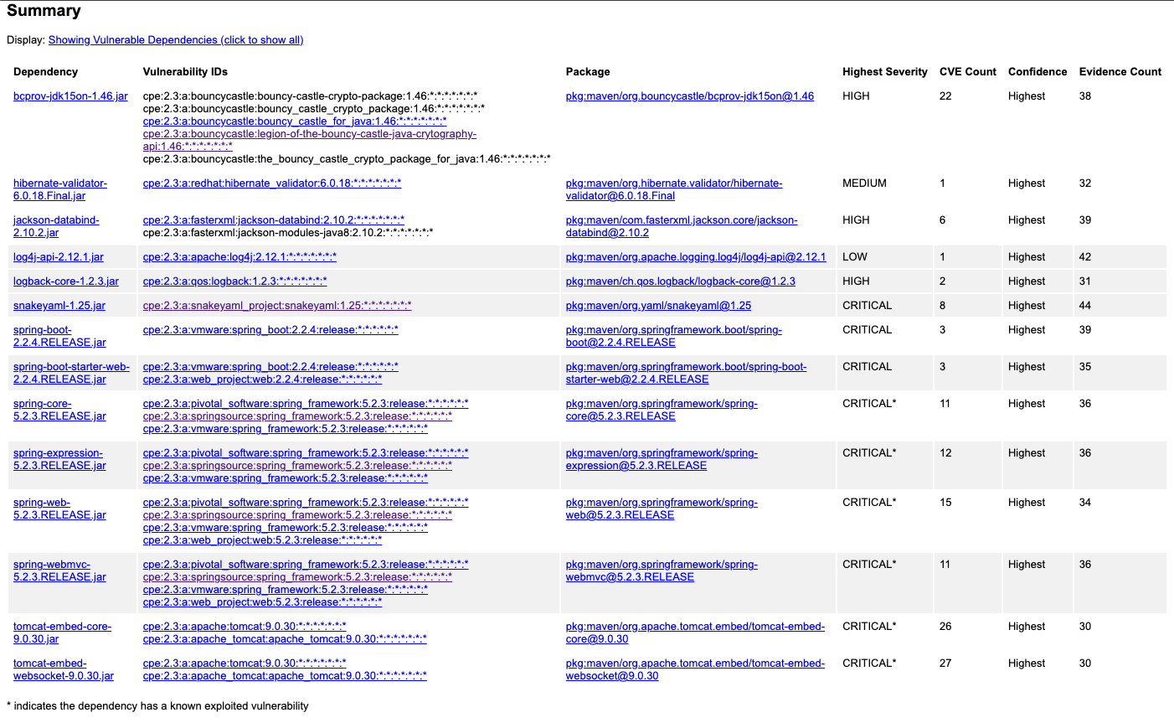

1. Dependency Report after suppression.

file:///Users/kevinbagayas/Downloads/CS%20305%20Module%20Six%20Code/rest-service/target/dependency-check-report.html#

See below screenshot where some of the vulnerabilities were suppressed. The summary list decreased taking out some of the dependencies.

